Data preparation and analysis

### Listing price

#calendar has unformatted price data  
calendar$price<-as.numeric(gsub('[$,]','',calendar$price))  
summary(calendar$price)

Min. 1st Qu. Median Mean 3rd Qu. Max. NA's   
 10.0 80.0 125.0 208.5 215.0 10000.0 2114655

#listings has unformatted data as well  
listings$price<-as.numeric(gsub('[$,]','',listings$price))  
summary(listings$price)

Min. 1st Qu. Median Mean 3rd Qu. Max.   
 10.0 80.0 119.0 206.2 199.0 13000.0

#remove na values  
c<-which((is.na(calendar$price)))  
calendar<-calendar[-c,] #1305030  
calendar$day<-weekdays(calendar$date)  
calendar$month<-month(calendar$date)  
stats<- calendar %>% summarise(mean=mean(price), median=median(price), stdDev=sd(price), q1=quantile(price,probs=0.25), q3=quantile(price, probs=0.75),n=n())

mean 208.501 median 125 stdDev 340.2615 q1 80 q3 215 n 1305030

### Outlier detection for listing price

#outlier detection for price  
skewness(calendar$price) #11

[1] 11.77741

iqr<-stats$q3 - stats$q1  
iqrm<-1.5*iqr  
od<-stats$q3 + iqrm  
ecdf(calendar$price)(od)

[1] 0.9049194

#90% of the data is retained after outlier detection  
  
cleaned_calendar<-calendar %>%  
 filter(price<od)  
od

75%   
417.5

skewness(cleaned_calendar$price) #1.1

[1] 1.138918

by_month<-calendar %>%  
 group_by(month) %>%  
 summarise(avg_price=mean(price))  
  
by_day<-calendar %>%  
 group_by(day) %>%  
 summarise(avg_price=mean(price))

The technique of outlier detection employed here is the 1.5IQR rule, after which approx. 90% of the data is retained which is a pretty satisfactory representation.

After cleaning the calendar for outliers, the price can be looked at from a monthly and day granularity level. The month of June saw the highest average price of around $220 while February saw the least of around $189

#Finding min and max values in the calendar data  
min(calendar$date)

[1] "2018-11-15"

max(calendar$date)

[1] "2019-11-20"

Another point to note is that the price and availability data is available for approx. a year i.e. from November 15 2018 to November 20 2019

### Most Frequent words used by hosts in descriptions

# unnest_tokens function to tokenise  
listings_words <- listings %>%  
 select(id, description, price, review_scores_accuracy, review_scores_rating) %>%  
 unnest_tokens(word, description) %>%  
 filter(!word %in% stop_words$word,  
 str_detect(word, "^[a-z']+$"))  
  
#plot the graph  
common_listings <- listings_words %>%  
 group_by(word) %>%  
 summarise(count = n()) %>%  
 top_n(n = 20, wt = count) %>%  
 ggplot() +  
 geom_bar(mapping = aes(x=reorder(word, count),  
 y=count),  
 stat="identity", fill = "blue") +  
 labs(title="Top 20 words described in listings",  
 y="Word count", x="Most common Words") +  
 coord_flip() +  
 theme_minimal()  
   
common_listings

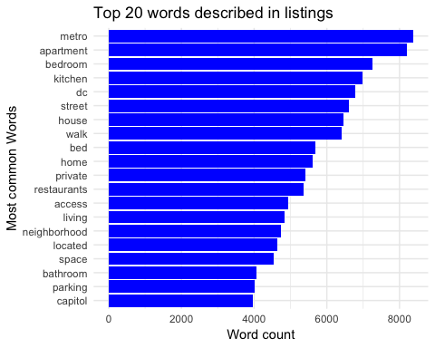

From the plot above of top 20 words in listing descriptions, it seems like most of the hosts mention about the proximity to metro in the description.

### Most Frequent words used by guests in reviews

# Using unnest_tokens function to takenise  
review_words <- reviews %>%  
 unnest_tokens(word, comments) %>%  
 filter(!word %in% stop_words$word,  
 str_detect(word, "^[a-z']+$"))  
  
op <- par(mar = c(9,4,4,2) + 0.1)  
#plot the graph  
common_reviews <- review_words %>%  
 group_by(word) %>%  
 summarise(count = n()) %>%  
 top_n(n = 20, wt = count) %>%  
 ggplot() +  
 geom_bar(mapping = aes(x=reorder(word, count), y=count),  
 stat="identity", fill = "orange") +  
 coord_flip() +  
 labs(title="Top 20 words described in Reviews",  
 y="Word count", x="Words") +  
 theme_minimal()+ scale_y_sqrt(labels = scales::comma)  
common_reviews

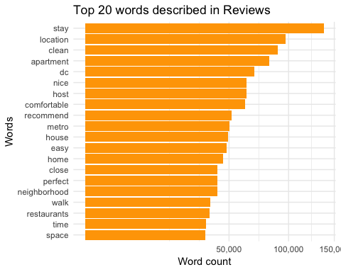

par(op)

From the above plot of top 20 keywords in reviews, it seems like stay, location, clean, host, comfort are some of the important factors that matter to the guests.

### Neighbourhood

factpal <- colorFactor(topo.colors(3), listings$neighbourhood_cleansed)  
  
popup <- paste0("<strong>'hood: </strong>", listings$neighbourhood_cleansed)  
  
leaflet(listings) %>% addProviderTiles("CartoDB.DarkMatter") %>%  
 addCircleMarkers(  
 color = ~factpal(neighbourhood_cleansed),  
 stroke = FALSE, fillOpacity = 0.5, radius = 1.2,  
 popup = ~popup  
 )

Assuming "longitude" and "latitude" are longitude and latitude, respectively

#Finding the count by group_by and sort  
listing_groupby<- listings %>%  
 group_by(neighbourhood_cleansed)  
count_list <- count(listing_groupby, sort = TRUE)  
kable(count_list)

|  |  |
| --- | --- |
| neighbourhood_cleansed | n |
| Columbia Heights, Mt. Pleasant, Pleasant Plains, Park View | 910 |
| Union Station, Stanton Park, Kingman Park | 906 |
| Capitol Hill, Lincoln Park | 858 |
| Edgewood, Bloomingdale, Truxton Circle, Eckington | 713 |
| Dupont Circle, Connecticut Avenue/K Street | 685 |
| Shaw, Logan Circle | 623 |
| Downtown, Chinatown, Penn Quarters, Mount Vernon Square, North Capitol Street | 499 |
| Brightwood Park, Crestwood, Petworth | 477 |
| Kalorama Heights, Adams Morgan, Lanier Heights | 423 |
| Howard University, Le Droit Park, Cardozo/Shaw | 362 |
| West End, Foggy Bottom, GWU | 350 |
| Georgetown, Burleith/Hillandale | 284 |
| Ivy City, Arboretum, Trinidad, Carver Langston | 245 |
| Takoma, Brightwood, Manor Park | 165 |
| Brookland, Brentwood, Langdon | 159 |
| Southwest Employment Area, Southwest/Waterfront, Fort McNair, Buzzard Point | 150 |
| Cathedral Heights, McLean Gardens, Glover Park | 140 |
| Cleveland Park, Woodley Park, Massachusetts Avenue Heights, Woodland-Normanstone Terrace | 129 |
| Lamont Riggs, Queens Chapel, Fort Totten, Pleasant Hill | 109 |
| Twining, Fairlawn, Randle Highlands, Penn Branch, Fort Davis Park, Fort Dupont | 109 |
| Spring Valley, Palisades, Wesley Heights, Foxhall Crescent, Foxhall Village, Georgetown Reservoir | 98 |
| Friendship Heights, American University Park, Tenleytown | 96 |
| Congress Heights, Bellevue, Washington Highlands | 86 |
| North Michigan Park, Michigan Park, University Heights | 84 |
| North Cleveland Park, Forest Hills, Van Ness | 83 |
| Capitol View, Marshall Heights, Benning Heights | 79 |
| Near Southeast, Navy Yard | 74 |
| Woodridge, Fort Lincoln, Gateway | 68 |
| Hawthorne, Barnaby Woods, Chevy Chase | 56 |
| Mayfair, Hillbrook, Mahaning Heights | 53 |
| Historic Anacostia | 50 |
| Colonial Village, Shepherd Park, North Portal Estates | 47 |
| Sheridan, Barry Farm, Buena Vista | 46 |
| Deanwood, Burrville, Grant Park, Lincoln Heights, Fairmont Heights | 42 |
| River Terrace, Benning, Greenway, Dupont Park | 40 |
| Douglas, Shipley Terrace | 28 |
| Fairfax Village, Naylor Gardens, Hillcrest, Summit Park | 21 |
| Woodland/Fort Stanton, Garfield Heights, Knox Hill | 13 |
| Eastland Gardens, Kenilworth | 9 |

From the plot and table above, we see that most number of listings are close to the neighbourhoods Columbia Heights, Union stations, Capitol Hill etc.

### Review score rating

review_desc <- listings$review_scores_rating  
summary(review_desc )

Min. 1st Qu. Median Mean 3rd Qu. Max. NA's   
 20.00 93.00 97.00 94.96 100.00 100.00 2214

As seen above, most of the guest who review give high scores.

### Different listings based on Room type

room_groupby<- listings %>%  
 group_by(room_type)  
count_room <- count(room_groupby, sort = TRUE)  
kable(count_room)

|  |  |
| --- | --- |
| room_type | n |
| Entire home/apt | 6614 |
| Private room | 2525 |
| Shared room | 230 |

### Property Type of listings

listings$property_type = ifelse(listings$property_type == "Apartment", "Apartment",   
 ifelse(listings$property_type == "Bed & Breakfast","B&B",  
 ifelse(listings$property_type == "Condominium","Condominium",  
 ifelse(listings$property_type == "House","House",  
 ifelse(listings$property_type == "Loft","Loft",  
 ifelse(listings$property_type == "Townhouse","Townhouse",  
 ifelse(listings$property_type == "Dorm","Dorm", "Other")))))))  
listings$property_type = as.factor(listings$property_type)

We have only kept Apartment, b&b, Condominium, House, Loft, Townhouse, and Dorm in Property.Type and the rest would be categorised to Others.

s <- unique(listings$property_type)  
  
cr <- data.frame(count_room)  
piepercent<- round(100*(cr$n/sum(cr$n)),2)  
bp<- ggplot(cr, aes(x="", y=n, fill=room_type))+  
geom_bar(width = 1, stat = "identity")  
pie <- bp + coord_polar("y")+geom_text(label=piepercent)+theme(axis.text.x=element_blank())  
pie

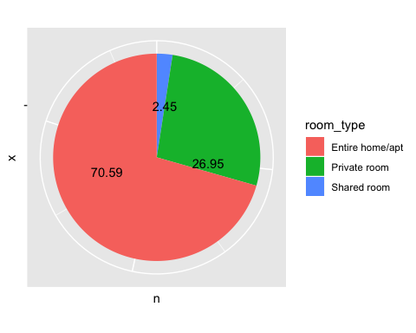

op <- par(mar = c(9,4,4,2) + 0.1)  
barplot(table(listings$property_type),col = "brown",las=2)

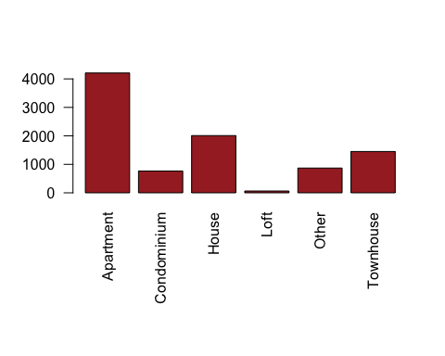

par(op)

The above pie chart shows people prefer entire property than private rooms or shared rooms. On exploring further about property type, it is seen that majority of the listings are Apartment, House, townhouse.